ANNEX 1



Horizon Europe (HORIZON)
Euratom Research and Training Programme (EURATOM)

[Description of the action (DoA)]
[for FPAs: Action plan]
Part A
Part B

Version 2.1
15 November 2022

IMPORTANT NOTICE
What is the Description of the Action (DoA)?
The Description of the Action (DoA) is the Annex of the Grant Agreement which contains the details of how the project will be carried out. For EU framework partnerships for grants (FPAs) this Annex is called Action Plan.
It consists of 2 parts, which must be generated from the submitted proposal:
- Part A contains structured tables with project information
- Part B is a narrative description on the work to be carried out.
Part A is generated by the IT system. It is based on the information which you enter into the Portal Grant Preparation screens.
Part B (+ annexes) must be uploaded on the Grant Preparation Documents screen.
Make sure that Part B is synchronised with the information entered into the screens. Make sure that any changes are agreed with us.

DESCRIPTION OF THE ACTION (PART A)
[for FPAs: ACTION PLAN (PART A)]
Part A of the Description of the Action (DoA) must be completed directly on the Portal Grant Preparation screens.
It will include:
COVER PAGE
TABLE OF CONTENTS
Project summary (automated – Based on proposal abstract)
List of participants (automated – Based on proposal information)
List of work packages (please fill in the data in the Portal Grant Preparation screen based on proposal table 3.1b)
Staff effort (please fill in the data in the Portal Grant Preparation screen based on proposal table 3.1f)
List of deliverables (please fill in the data in the Portal Grant Preparation screen based on proposal table 3.1c)
List of milestones (please fill in the data in the Portal Grant Preparation screen based on proposal table 3.1d) (n/a HE ERC)
List of critical risks (please fill in the data in the Portal Grant Preparation screen based on proposal table 3.1e) (n/a HE ERC)
Research infrastructure (if applicable)
ERC PI information (if applicable)
JU contributions (if applicable)

DESCRIPTION OF THE ACTION (PART B)
[for FPAs: ACTION PLAN (PART A)]
[OPTION 1 by default:
Part B of the Description of the Action (DoA) must be uploaded on the Portal Grant Preparation Documents screen.
HOW TO MAKE YOUR PART B
- Start from Part B of your proposal. Use the version that was submitted for evaluation.

The version used should be the submitted version of the proposal (— unless you have been explicitly requested to make changes). All changes need to be discussed and agreed with the EU Project Officer. Substantial changes to the proposal are NOT allowed.
- Remove the cover page, if any.
- Delete the header, if any.
- Replace the footer with the following information ‘[Proposal number] [Proposal acronym] – Part B – [Page number (starting at 1 for Part B)]’.
- Remove the list of participants. This is included in Part A.
- Remove tables 3.1a (list of work packages), 3.1b (work packages descriptions), 3.1c (list of deliverables), 3.1d (list of milestones), 3.1e (critical risks for implementation) and 3.1f (summary of staff effort) from section 3.1 (they are encoded in the screens and included in Part A). Keep tables 3.1g, 3.1h, 3.1i and 3.1j (and any other table linked to specific types of actions).

For lump sum grants, please make sure to delete also other tables related to project costs, i.e. tables 3.1h (purchase costs), 3.1i (other cost categories), 3.1j (in-kind contributions provided by third parties).
- Create a section 4 ‘ethics self-assessment’ and copy into this section the ethics self-assessment you included in the proposal Part A.
- Cross-check all sections in order to implement changes required by/agreed with the EU. Ensure coherence with the information entered on the screens.
- Add a table with the history of changes.

Specify all changes compared to your proposal. Changes should be described concisely. You do not need to include minor changes that do not modify the substance of the DoA (e.g. correction of spelling and grammar, changes in formatting).
- Add a table of contents with page numbers (or update the existing table of contents).
- Merge all parts of Part B into a single file, Convert the final Part B into PDF format and upload the PDF on the Portal Grant Preparation Documents screen.

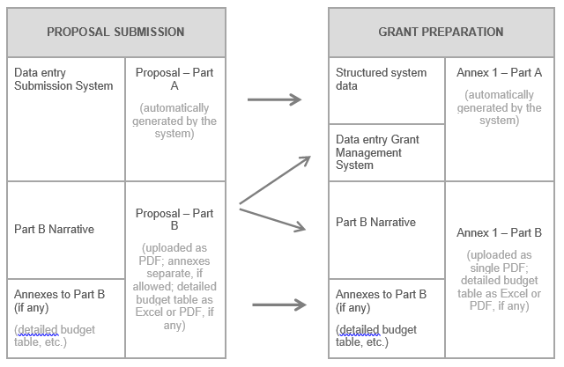

]
[OPTION 2 for HE ERC Starting Grants/Consolidator Grants/Advanced Grants/Synergy Grants:
Part B of the Description of the Action (DoA) must be uploaded on the Portal Grant Preparation Documents screen.
HOW TO PREPARE YOUR GAP ANNEXES
Annex 1 Description of the Action (DoA)
Annex 1 — Part A
- Part A is generated automatically by the system from the information provided in the online forms.
Annex 1 — Part B
- To create Part B, you must merge Part B1 and Part B2 from the proposal into a single document.
In addition, for all actions (except SyG where the description of resources is already in the part B), you must add, for each beneficiary and affiliated entity, the description of the resources from the proposal Part A Section C (narrative description; not the budget table).
The final document needs to be uploaded as a PDF document in the system.
- Please remember to:
  - update the funding ID
  - remove the cover page, if any
  - delete the header, if any
  - replace the footer with the following information ‘[Proposal number] [Proposal acronym] – Part B – [Page number (starting at 1 for Part B)]’
  - for the description of resources:
  - copy/keep at the end of Part B the narrative description from the proposal and update it if necessary
Ensure that, for each cost category, there is a clear link between the description and the budget foreseen in Annex 2.
Please make sure that the description is complete; add the description of any resource that may be incomplete or missing in the proposal.
  - include a short justification for the involvement of the external experts and add the costs under the cost category C.1 Travel and subsistence of Annex 2, if the participation of external experts in the action is necessary for the action
  - include a description of any third party providing in-kind contribution for free, if applicable
  - use whole Euro values only
Annex 2 Budget
- Annex 2 is generated automatically by the system from the information provided by you in the Portal Grant Preparation Financial Information screen.
- Please ensure coherence between the description of resources (included in Annex 1 – Part B) and the amounts provided in Annex 2 (budget table).
- If you requested additional funding which was approved by the panel, include the relevant costs in the dedicated separate lines in the Financial Information screen (D. Other cost categories).
Depending on the underlying types of costs, allocate them either under sub-category D.7 ERC additional funding (i.e. personnel and purchases) or D.8 ERC additional funding (i.e. subcontracting, FSTP and internally invoiced goods and services). The latter category will not be taken into account for the indirect cost flat-rate.
For instance, additional funding related to costs of equipment should be allocated to D.7, while additional funding related to subcontracting, should be allocated to D.8.

Summary

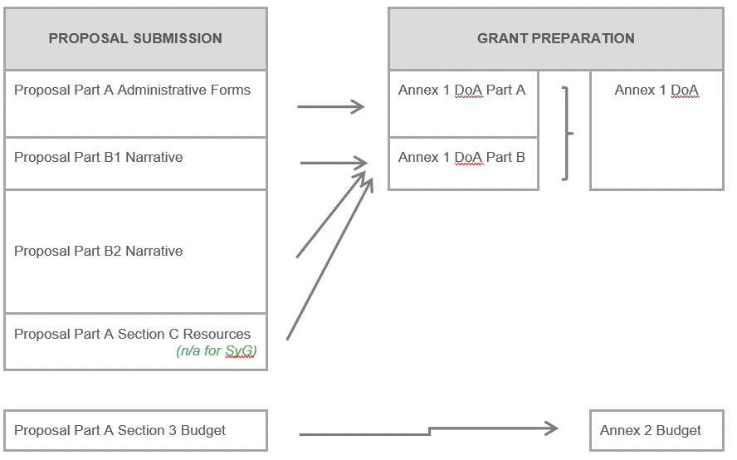

]
[OPTION 3 for HE EIC Accelerator actions:
Part B of the Description of the Action (DoA) must be uploaded on the Portal Grant Preparation Documents screen.
HOW TO PREPARE YOUR GAP ANNEXES
Annex 1 Description of the Action (DoA)
Annex 1 — Part A
- Part A is generated automatically by the system from the information provided in the online forms.
Annex 1— Part B
- As Part B, you must upload the business plan agreed during the negotiation phase.
Annex 2 Budget
- Annex 2 is generated automatically by the system from the information provided by you in the Portal Grant Preparation Financial Information screen.
Annex 6 Investment agreement
- Annex 6 will be added later on through an amendment to the Grant Agreement, based on the text agreed with you during the negotiations.

]

HISTORY OF CHANGES
VERSION | PUBLICATION DATE | CHANGE
1.0 | 15.06.2021 | Initial version (new MFF).
2.0 | 15.01.2022 | Update to include HE ERC instructions, HE EIC ACC BF instructions and JU contribution table.
2.1 | 15.11.2022 | Update for Lump Sum grants.

